**DBMS ASSIGNMENT 3**

**NAME: Abhijit Gawai**

**ROLL NO: 18 (batch 1)**

**GR NO: 11810895**

Problem Statement: Create tables for the above schema using DDL queries. Apply appropriate constraints. Alter the table design by adding/removing column and constraints. Write DML statements to modify data in tables

1. **Customer(customer_name, customer_number, phno, DOB, age, city, area, street, flat_no)**

3NF:

**Customer5 (customer_fname, customer_lname, customer_number, phno, DOB, city, area, street, flat_no)**

and

**Customer6 (DOB, age)**

**Customer5 (customer_fname, customer_lname, customer_number, phno, DOB, city, area, street, flat_no)**

**Initializing table:**

create table Customer5(customer_fname varchar(30) , customer_lname varchar(30) , customer_number int , phno int , DOB varchar(30), city varchar(30), area varchar(30) , street varchar(30), flat_no int );

**Inserting values:**

insert into Customer5(customer_fname, customer_lname, customer_number, phno, DOB, city, area, street, flat_no) values('abhijit','gawai', 1, 9130115171, '16/01/2000', 'akola', 'gaurakshan' , 'k.Lawns', 201);

**Displaying table:**

select * from Customer5

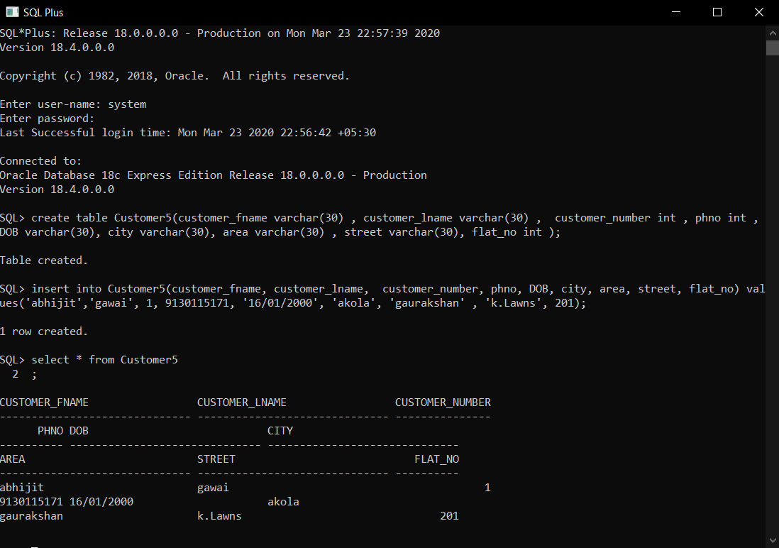

**Customer6 (DOB, age)**

**Initializing table:**

Customer6(DOB, age)

create table Customer6(DOB varchar(30), age int);

**Inserting values:**

insert into Customer6(DOB, age) values('16/01/2000', 20);

**Displaying table:**

select * from Customer6;

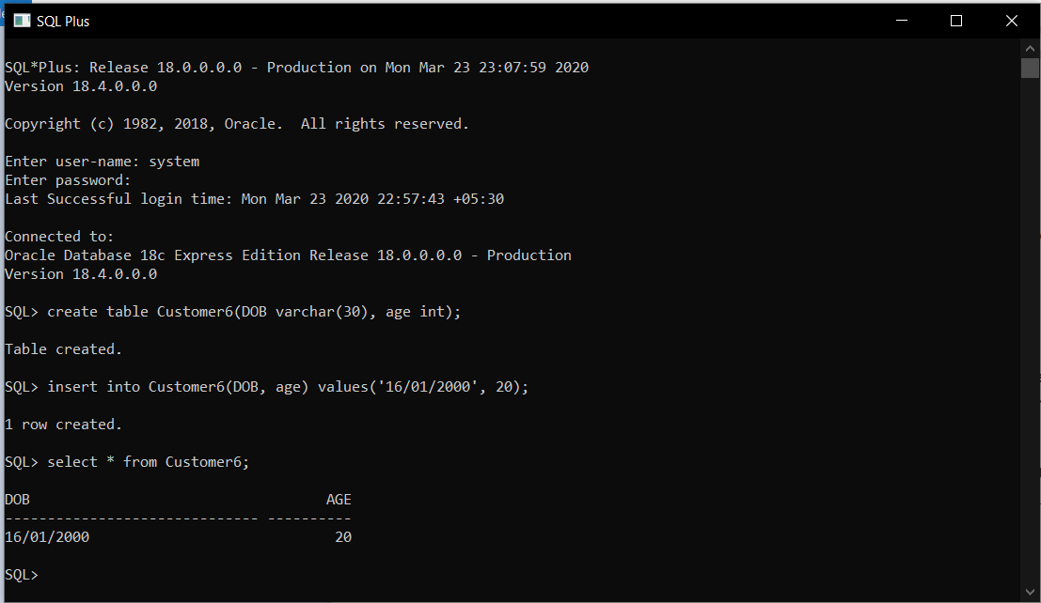

1. **Mall(Mall_name, location, category, brand_s, total_visits, total_bill_paid, avg_bill_paid)**

3NF:

**Mall1 (Mall_name, city, area, category, brand_s, total_visits, total_bill_paid)**

and

**Mall2 (total_visits, total_bill_paid, avg_bill_paid)**

**Mall1 (Mall_name, city, area, category, brand_s, total_visits, total_bill_paid)**

**Initializing table:**

create table Mall1(Mall_name varchar(30), city varchar(30), area varchar(30), category varchar(30), brand_s varchar(30), total_visits int, total_bill_paid int);

**Inserting values:**

insert into Mall1(Mall_name, city, area, category, brand_s, total_visits, total_bill_paid) values('Central Mall', 'pune', 'hadpsar', 'clothing', 'central', 10, 50000);

**Displaying table:**

select * from Mall1;

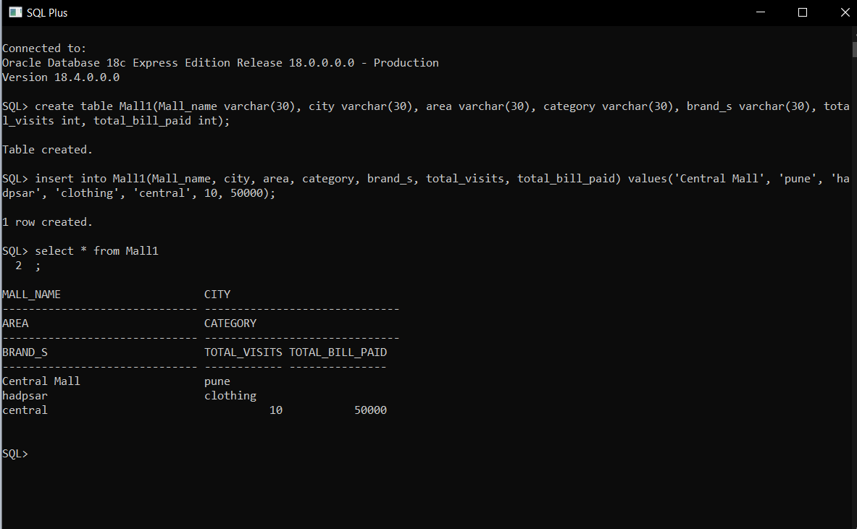

**Mall2 (total_visits, total_bill_paid, avg_bill_paid)**

**Initializing table:**

create table Mall2 (total_visits int , total_bill_paid int , avg_bill_paid int);

**Inserting values:**

insert into Mall2(total_visits, total_bill_paid, avg_bill_paid) values(10, 50000, 5000);

**Displaying table:**

select * from Mall2; 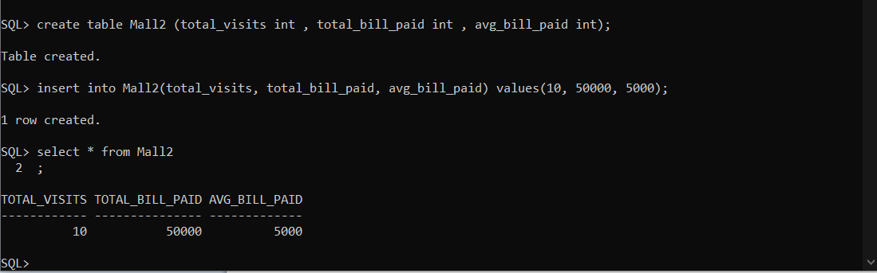

1. **Products (RFID_tagno, Product_name, Quantity_of_Product, Price_of_Product, Total_price_of_Product, Product_brand, Product_catagory, location_in_shop)**

3NF:

**Products1 (RFID_tagno, Product_name, Quantity_of_Product, Price_of_Product, Product_brand, Product_catagory, location_in_shop)**

And

**Products2 (Quantity_of_Product, Price_of_Product, Total_price_of_Product)**

**Products1 (RFID_tagno, Product_name, Quantity_of_Product, Price_of_Product, Product_brand, Product_catagory, location_in_shop)**

**Initializing table:**

create table Mall1(**Mall_name varchar(30), city varchar(30), area varchar(30), category varchar(30), brand_s varchar(30) total_visits int, total_bill_paid int**);

**Inserting values:**

insert into Mall1(**Mall_name, city, area, category, brand_s, total_visits, total_bill_paid**) values('Central Mall', 'pune', 'hadpsar', 'clothing', 'central', 10, 50000);

**Displaying table:**

select * from Products1;

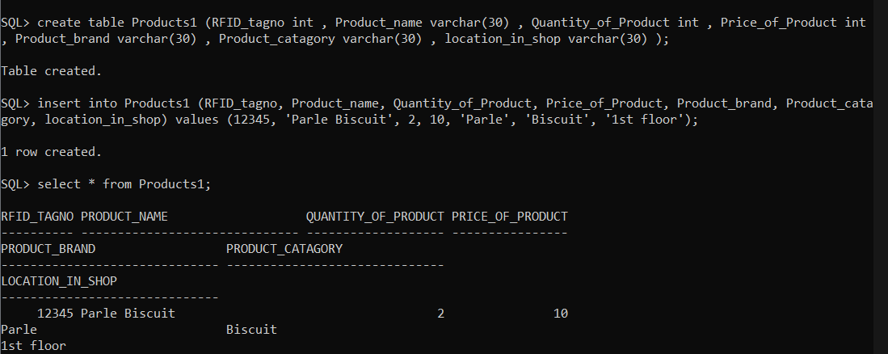

**Products2 (Quantity_of_Product, Price_of_Product, Total_price_of_Product)**

**Initializing table:**

create table **Products2 (Quantity_of_Product int , Price_of_Product int , Total_price_of_Product int );**

**Inserting values:**

**insert into Products2(Quantity_of_Product , Price_of_Product , Total_price_of_Product ) values (2,10,20);**

**Displaying table:**

select * from Products2;

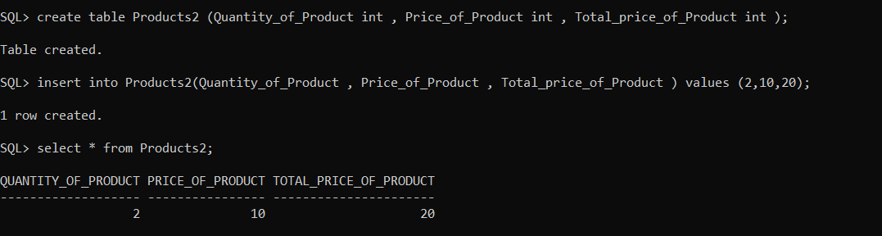

1. **Bill (Bill_no, Transaction_id, Payment_mode, Payment_status, Total_bill)**

**3NF:**

**Bill (Bill_no, Transaction_id, Payment_mode, Payment_status, Total_bill)**

**Initializing table:**

**create table Bill (Bill_no int , Transaction_id int , Payment_mode varchar(30) , Payment_status varchar(30) , Total_bill int );**

**Inserting values:**

**insert into Bill (Bill_no, Transaction_id, Payment_mode, Payment_status, Total_bill) values (1212, 1212,'Gpay','Done', 50000 );**

**Displaying table:**

select * from Bill;

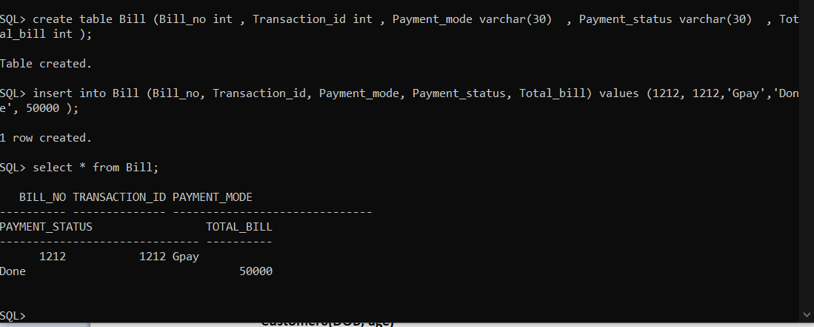

1. **Vehicle (Vehicle_number, Type_of_vehicle, Parking_fee, Parking_location)**

**3NF:**

**Vehicle (Vehicle_number, Type_of_vehicle, Parking_fee, Parking_location)**

**Initializing table:**

**create table Bill (Bill_no int , Transaction_id int , Payment_mode varchar(30) , Payment_status varchar(30) , Total_bill int );**

**Inserting values:**

**create table Vehicle (Vehicle_number varchar(30) , Type_of_vehicle varchar(30) , Parking_fee int , Parking_location varchar(30) );**

**Displaying table:**

select * from Vehicle;

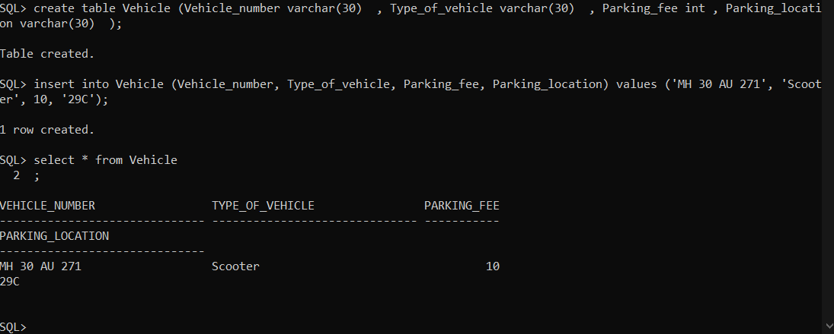

1. **Shop (Shop_no, Shop_total_bill ,Shop_catagory, Shop_brand, Floor)**

**3NF:**

**Shop (Shop_no, Shop_total_bill ,Shop_catagory, Shop_brand, Floor)**

**Initializing table:**

**create table Shop (Shop_no int , Shop_total_bill int ,Shop_catagory varchar(30) , Shop_brand varchar(30) , Floor int );**

**Inserting values:**

**insert into Shop (Shop_no, Shop_total_bill ,Shop_catagory, Shop_brand, Floor) values (17, 50000, 'Clothing', 'HnM', 2);**

**Displaying table:**

select * from Shop;

